Final Project Report

For

Sports Aggregator

Information System

ISM 6124 – Advanced Systems Analysis/Design

Prepared by:

Rohith Movva (U34473539)

USF Muma College of Business

07th November, 2017

Abstract

Sports Aggregator Information System is a uniquely designed system which has both expert and user interactive content focusing audiences from the range of novice to expert level sports enthusiasts. There are many existing information systems which are either expert systems or user interactive systems alone, but we have combined the features of both systems. Our information system will provide more specific content to the users by displaying the notifications, articles, match details etc., only of the sports the user is interested and subscribed to. Sports Aggregator Information System also has the provision for booking the tickets for different matches held across the globe. This system is a one stop solution for sports enthusiasts for score updates, player statistics, critical analysis, ticket booking. This system also has email notifications about a new match, any interesting move of the user’s favorite sports person. In short, Sports Aggregator Information System has every information of sports required by sports enthusiasts under one system. This system covers 9 major international sports and has a future scope of increasing the number of sports further.

Table of Contents

Contents

1. Introduction 1

1.1 Objective 1

1.2 Functional Overview 1

1.2.1 Problem 1

1.2.2 Investigation 1

1.2.3 Solution 2

1.2.4 Market Scope 2

1.3 Product Scope 2

2. System Requirement Specifications 3

2.1 Product Perspective 3

2.2 Product Functions 3

2.3 User Classes and Characteristics 4

2.4 Operating Environment 6

2.5 Design and Implementation Constraints 7

2.6 User Documentation 7

3. External Interface Requirements 7

3.1 User Interfaces 7

3.2 Hardware Interfaces 8

3.3 Software Interfaces 8

3.4 Communications Interfaces 8

4. Functional Requirements 8

4.1 Purchasing Tickets 8

4.2 Users Posting an article 10

4.3 Agents Posting an article 10

5. Input Requirements 13

5.1 User Identifier key and user access 13

6. Process Requirements 13

6.1 Database Transaction 13

6.2 Data Integrity 13

6.3 Validation of Data 13

7. Output Requirements 14

8. Other Nonfunctional Requirements 14

8.1 Performance Requirements 14

8.2 Safety Requirements 14

8.3 Security Requirements 14

8.3.1 User Log-in access security 14

8.3.2 Communication security 15

8.4 Software Quality Attributes 15

8.4.1 Adaptability 15

8.4.2 Flexibility 15

8.4.3 Portability 15

8.4.4 Usability 15

8.4.5 Availability 15

8.4.6 Reliability 15

8.5 Business Rules 15

9. Other Requirements 16

9.1 Deployment Requirements 16

10. Outlook of Sports Aggregator Information System 17

10.1 Backend View: Database Design 17

10.2 Frontend View: Graphical User Interface 20

11. Conclusions 22

12. Recommendations 22

13. Lessons Learned from Project and Course 23

# Introduction

## Objective

This report elaborately discusses about the system analysis design of a new information system named “Sports Aggregator” which has taken the reference from the existing information system “sportskeeda.com”. As part of this, problems in existing systems, investigating the existing systems, solution derived from those investigations, market scope of the new system, Software Requirements Specifications and the final interfaces, the future scope of this system.

## Functional Overview

### Problem

The existing system “sportskeeda.com” is an information system which provides sports news of multiple international sports and it is a user interactive system where the content is provided by users of the system rather than having an expert system. As it is just a user interactive system there is no authentication for the articles posted in the system.

We also have well-known sports news information system “Yahoo Sports” which is completely an expert system but there is no provision for the users’ to publish their own articles or give their critical analysis related to a sport.

In both these existing systems, articles and information is provided for all the available sports irrespective of the interest of the user.

So, in the new information system “Sports Aggregator” we are addressing the above problems i.e., by providing both user interactive and expert systems which are the USP’s of each of the systems mentioned above and users’ will be allowed to select their interested sports during registration which ensures to display the information and articles related only to his/her interests.

### Investigation

As part of our initial investigation, we have thoroughly studied various major functionalities of both the existing systems, understood the working model scenarios and design of the systems lucidly. From these understandings, we learned that both these systems are concentrating on all the major international sports and they are not able to meet few requirements of their users’. Later, as part of our investigation we directly interacted with the users to understand their requirements by posting below questionnaire.

## 

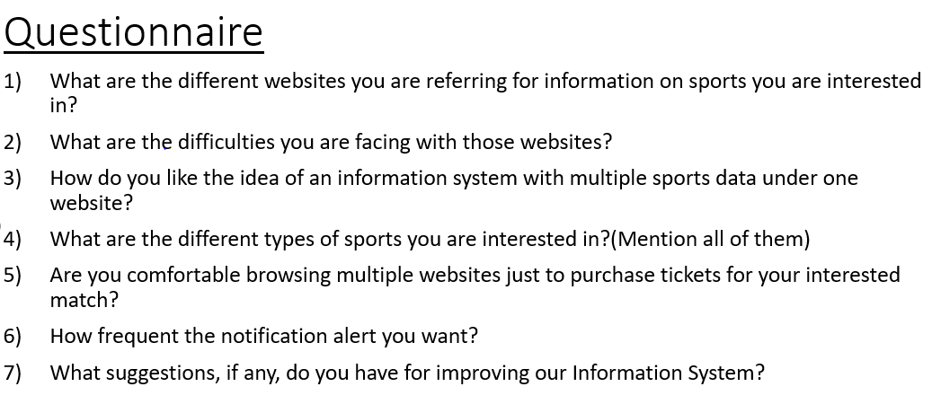

From the feedback we received from the users’ we learned that most of the users are looking for an information system which is going to be both expert as well as user interactive.

### Solution

Sports Aggregator information system provides the following solutions:

* User can select his interested sports and be rest assured of being notified of only the articles and information pertaining only to those sports.
* User can post their own articles related to their interested sports which will be validated by the respective experts (Agent) and then it will be available for consuming for all the users.
* User will be notified over an email regarding the upcoming tournaments in their interested sports.
* Users’ can get statistical information regarding their interested players and tournaments.
* This system has the provision to purchase tickets for the tournaments by redirecting to the respective vendors.

### Market Scope

Sports Aggregator Information System mainly targets sports enthusiasts to increase the hits on the system which in turn attracts the advertisements there by increasing the number of ticket vendors.

## Product Scope

As Sports Aggregator Information System provides lots of information regarding various aspects of sports which leads to handling of huge data, due to some implementation constraints (like handling data using Oracle Database, …) we have restricted our scope to only 9 major international sports (Badminton, Baseball, Basketball, Cricket, Football, Golf, Hockey, Tennis and Volleyball).

# System Requirement Specifications

## Product Perspective

As mentioned above, this Information system should address the issues faced with existing systems by providing both expert and user-interactive system. The below is the simple architecture diagram that depicts the various components in the system which provides the solution for the issue.

## 

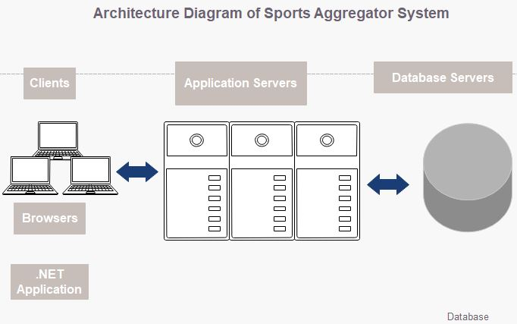

*Fig 1 Architecture Diagram of Sports Aggregator Information System*

## Product Functions

In this Information System, the major functions performed are as follows:

* Users’ can get awareness about a sport
* Users’ can register to the system for updates on interested sports.
* Users’ can view Players, tournaments and ticket vendors details
* Users’ can post their articles about a sport
* Agents updates the database with Players, tournaments and ticket vendors details.
* Agents provide latest updates about sport to all respective users.
* Agents posts articles and validates the articles posted by users.
* Manager updates the sports details

## 

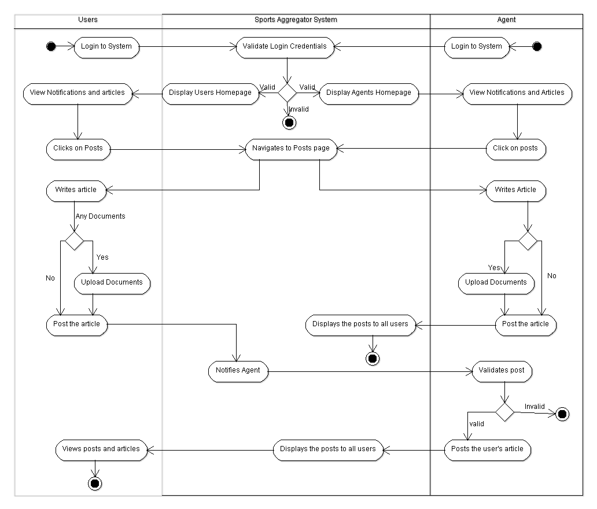

*Fig 2 Activity Diagram of Sports Aggregator Information System*

## User Classes and Characteristics

The actors in this information system are pre-dominantly Users, Agents, Managers and Ticket_Vendors.

* **Users**: The Users should register to Sports Aggregator system by selecting his/her interested sports and log-in to system to view the latest updates in their interested sports, player statistics, tournament details, purchase tickets for the tournaments by navigating to the respective Vendor’s page and post the articles.
* **Agents:** The Agents updates the database with the player, tournament and ticket vendors details. Also, Agents posts his/her articles and validates the articles posted by users before publishing it to all users of the system. And agents provide the notifications/latest updates of a sport to the respective users.
* **Managers:** The Manager will recruit the agents for various sports and creates their profile in the system. Manager is the only one who adds/updates/deletes the sports details in the system. Manager posts messages to the agents.
* **Ticket_Vendors:** Ticket_vendors provide the URL link details for purchasing tickets for the tournaments, which later validated by agent and updated into the system.

## 

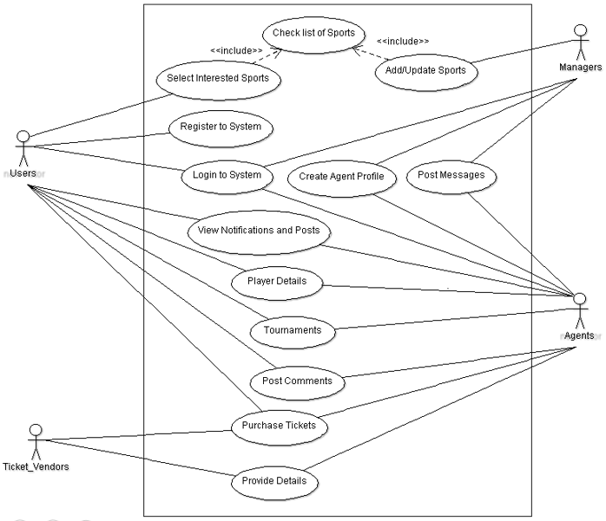

*Fig 3 Use Case Diagram of Sports Aggregator Information System*

## 

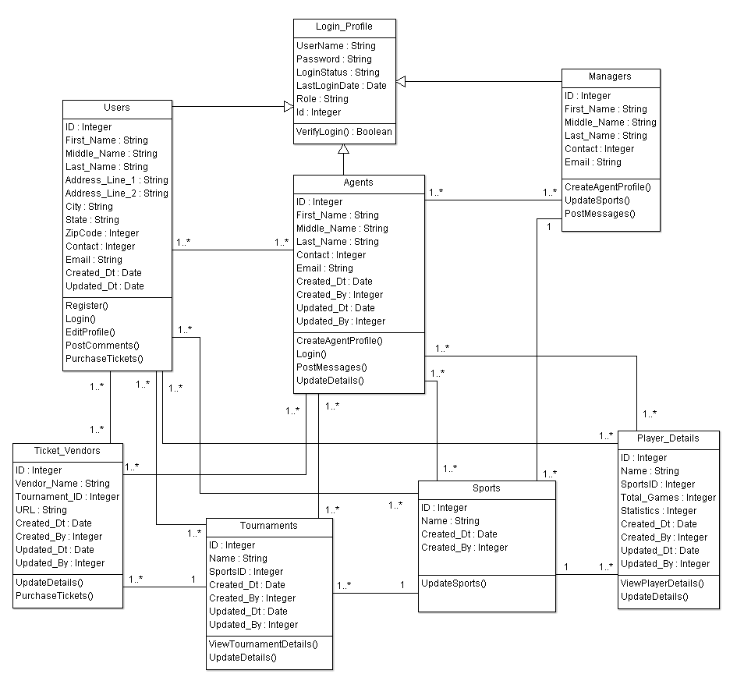

*Fig 4 Class Diagram of Sports Aggregator Information System*

## Operating Environment

* **Hardware Platform:** The minimum hardware platforms required for this information system are Apache Web Server (Apache 2.4.28 installed), Application Server (Weblogic 12c installed) and an Oracle Database server (Oracle 12c installed).
* **Operating Systems:** Windows and Linux
* **Browsers:** Internet Explorer, Mozilla Firefox, Google Chrome

## Design and Implementation Constraints

* **Language Requirements:** The Graphical User Interface will have only English language.
* **Database Requirements:** For storing and managing large amounts of data (like users details, players, tournaments, vendors details etc….), we need to use the Oracle 12c database.
* **Communication Protocols:** HTTP and HTTPS.
* **Programming Standards:**
  + Use comments while designing and implementation of code.
  + Follow the naming convention standards of the respective programming language while implementing.
  + Create global methods for the code which is being used frequently.

## User Documentation

There shall be three types of manuals. The actors can be Users, Agents or Managers. The manual for Users’ will contain the details about Registration page information, log-in information; password reset steps, steps to view articles, players, tournaments and vendors details, along with this it will have steps to post an article by the user. The Agents manual contains the details about the steps to send notifications and updates to users, steps to validate the articles posted by the users and publish them to all users. The Managers manual contains the steps to update the sports details, create agent’s profile and post messages to agents. Along with these manuals, an on-line help shall be delivered along with software. Separate FAQs section on the application tab shall host the on-line help. The Users’ questions can also be addressed over the emails by Agents or Manager.

# External Interface Requirements

## User Interfaces

* Whenever users’ hit the website URL, then a home page must be displayed with the image buttons of the sports provided by system. If the users are new to this system then they should be able to register to the system, else they can login to system by using their respective username and password.
* The Users’ should be allowed to view the latest updates, players, tournaments and vendors details in the respective pages and should be able to posts the articles.
* The Agents should be allowed to send notifications to users about updates in their interested sports.
* The Agents only should be allowed to validate the articles posted by users’ and then publish the valid articles to all users’.
* The Manager only should be allowed to update the sport details in the system.

## Hardware Interfaces

Hardware interfaces are not required as the communication between the components takes place as mentioned in section 3.4.

## Software Interfaces

* **Clients(Members/Treasurer/Administrator):** Operating System, Browsers
* **Apache Webserver:** Operating System, Apache HTTP server (Apache 2.4.28)
* **Application server:** Operating system, weblogic 12c
* **Database Server:** Operating system, Oracle 12c database
* ASP.NET, C#, JavaScripts, PL/SQL, Microsoft Visual Studio and SQL Developer

## Communications Interfaces

* The user’s machine communicates with the Apache webserver by the protocols HTTPS, which is highly secured.
* The communication between Apache webserver and Application weblogic server is taken by configuring the Apache Weblogic cluster with the respective weblogic server details (like IP, port, etc…)
* The application weblogic server communicates with the database server by configuring the JDBC connection details in weblogic.
* The SMTP protocol configured in both application and database servers to send reminders from application to users.

# Functional Requirements

The following 3 are one of the most important features

## Purchasing Tickets

### Description and Priority

Firstly, the users’ Logins to system and then views the latest tournament details of their interested sports. Then navigates to tickets page and inputs the sport and tournament details. Then checks the vendors list and then purchase ticket by navigating to vendors page. Priority is high since this is one of the major functions of the Sports Aggregator system.

### Stimulus/Response Sequences

**Stimulus:** Users’ requests for Login

**Response:** System displays the Login page where member needs to enter username and password to login to system.

**Stimulus:** Users’ enters their credentials and clicks login

**Response:** System validates the credentials and then displays the Home page of the user with the latest updates in their interested sport.

**Stimulus:** Users’ clicks on the tickets tab

**Response:** System navigates to tickets page.

**Stimulus:** Users’ input the sport and tournament details.

**Response:** Systems displays the vendor’s list related to the inputs given by user.

**Stimulus:** Users’ click on their interested vendor for purchasing the tickets

**Response:** System must navigate to the respective vendors page.

### Functional Requirements

#### Functional Requirement 1

REQ-1: Users’ Login

DESC: Here the user is already registered to the system; the user must be able to login to system by entering the username and password.

#### Functional Requirement 2

REQ-2: Users’ tickets page

DESC: Here the User must be allowed to input the sport and tournament details for which they are interested to purchase the tickets.

#### Functional Requirement 3

REQ-3: Vendor’s list

DESC: The User must be allowed to navigate to vendor’s page by clicking on their interested vendor from the list.

## Users Posting an article

### Description and Priority

Firstly, the users navigate to posts page. Then they input sport and then provide a brief description about the article and upload any documents if available. Priority is high as it is the major function that provides solution for the problems discussed in the section 1.2.1.

### Stimulus/Response Sequences

**Stimulus:** Users’ clicks on the Posts tab

**Response:** System navigates to Posts page.

**Stimulus:** Users’ input the sport detail and then provide a description on article along with any documents if any available.

**Response:** Systems displays the description provided by user, allows user to upload documents and enables the post button.

**Stimulus:** Users’ click on post button

**Response:** System displays a success message and notifies agents about this article.

### Functional Requirements

#### Functional Requirement 4

REQ-4: Posts article

DESC: The user who has already registered to system can select sport and post an article related to that sport, which will be notified to an agent for validation of the article.

## Agents Posting an article

### Description and Priority

The Agents posts their articles, also validates the articles posted by users and publish the articles which are valid among them to all the users of the system who are interested in that sport. Priority is high as it is the major function that provides solution for the problems discussed in the section 1.2.1.

### Stimulus/Response Sequences

**Stimulus:** Agent Logins to system with his/her credentials.

**Response:** The System navigates to Home page of Agent.

**Stimulus:** Agent requests to view the articles posted by users

**Response:** System displays the articles posted by users along with the documents uploaded by users if any.

**Stimulus:** Agents validates article and clicks on post if they are valid

**Response:** System displays that article in the homepage of all users who are interested in that sport.

### Functional Requirements

#### Functional Requirement 5

REQ-5: Validate and post article

DESC: Agent Login to system and validates the articles and posts it to all users of that sport.

# 

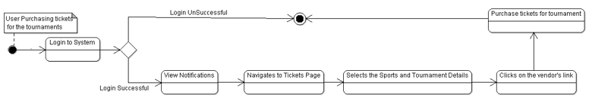

*Fig 5 State Diagram for Users purchasing tickets for the tournaments*

# 

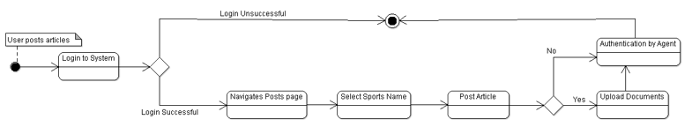

*Fig 6 State Diagram for Users posting an article*

# 

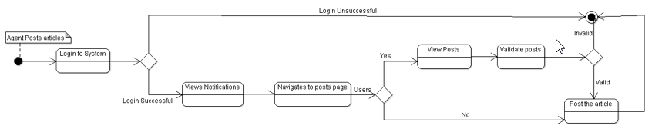

*Fig 7 State Diagram for Agents posting an article*

# 

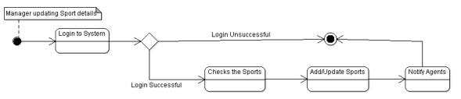

*Fig 8 State Diagram for Manager Updating Sports*

# 

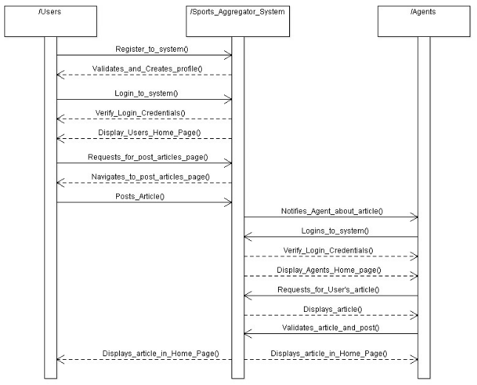

*Fig 9 Sequence Diagram of Sports Aggregator Information System*

# Input Requirements

## User Identifier key and user access

Each Actor (Users/Agents/Manager) is assigned with a unique identifier upon registering to the system. Users’ must know this key. These keys will be mapped to all actions performed by the respective user in system. Users’ may input their respective username and password while logging into system. Users’ must input same during registration whereas some fields are mandatory.

# Process Requirements

The Process requirements of this system are as follows:

* The system must provide the users to follow steps for their transactions as mentioned in user documentation for the processes like registration, Log-in and post articles.
* The Agent must be allowed to validate articles and to send reminders to users.
* The Manager must be allowed to have access to manage the sports and Agent information.

The following are some more Process Requirements that the Sports Aggregator Information System must be able to handle

## Database Transaction

The system must handle to send, receive and trigger the transactions to database for registration and posting articles.

## Data Integrity

The system must commit the transactions that have been completed. And also should rollback the transactions that were time-out or unfinished.

## Validation of Data

The system must gracefully handle the errors in data from the user’s end or from backend database processing end. There should be some data validation methods (or error handling methods) in the system.

# Output Requirements

* Each User must have a view of actions summary performed for a particular session. The database will be able to display all the successfully committed transactions in that session.

The following are the output requirements to the respective actors of the system:

* **Users:** The users should be displayed with the output messages based on functionality like Registration completed successfully/failed message for Registration to system, display the proper player, tournament and vendor details by fetching from database, Article posted successfully.
* **Agent:** The Agent should be displayed with a message as “Article posted by <Name> has been published successfully/failed” when posting a user’s article. And messages like “Reminder sent successfully/failed to <Name>” while sending reminders to users for updating about upcoming tournaments.
* **Manager:**  He/she should be displayed with message as “Sport <Name> has been added/updated in the system” when updating sports details. And message like “Profile has been created for agent <Name>” when creating a profile for a new agent.

# Other Nonfunctional Requirements

## Performance Requirements

* The average response time for loading the webpages should not be more than 2 to 3 seconds.
* The system must not get into the deadlock situations at any time.

## Safety Requirements

A Safety requirement is a kind of defensibility requirement, as this is a software product there will not be any loss of information between components due to use of transfer protocols, so there are no specific safety requirements.

## Security Requirements

### User Log-in access security

As mentioned in section 5.1, each user will have a unique username for log in to system, along with this the user account is secured by limiting the number of wrong passwords to 3. If the limit crosses then the account will be locked, to unlock the account the user has to use his/her registered mail Id.

### Communication security

The communication between the various components has to be done through the secured protocols like HTTPS, Siteminder SSO (Single sign-On) authentication, etc…. These will prevent the loss of information while transferring information between components like user machines to Apache webserver.

## Software Quality Attributes

### Adaptability

The system should be adaptable to different circumstances like work in all versions of the Operating environment.

### Flexibility

The system must be flexible to make changes in it if there are any altered conditions like if there are any further requirements needs to be added in the system.

### Portability

The application must work on desktop and mobile.

### Usability

The User Interface of application should be user friendly, easy to navigate.

### Availability

The system should be available on a 24*7 basis to all the users except a 2 hours interval between 01:00AM to 03:00 AM on Sundays for maintenance activities (like deployments, restart of the apache/weblogic servers, disk space clean up, etc…)

### Reliability

The search quality of the database should be highly reliable.

## Business Rules

In situations like delivering the product by dead-lines, the developers will also test the application along with the testing team to achieve the target.

# Other Requirements

## Deployment Requirements

For deploying the application to the application server we can use Tortoise SVN where developers can check-in their code from local machine to a repository and Jenkins tool which can be used for continuous deployments, that picks up the latest code from SVN and deploy it in the application server.

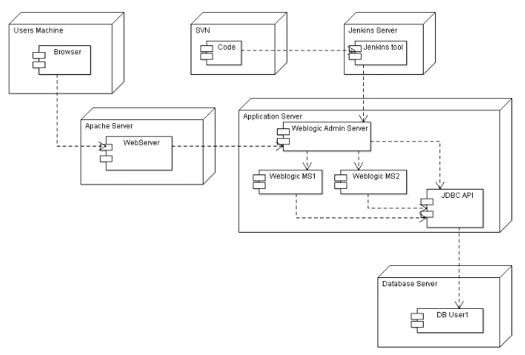

*Fig 10 Deployment Diagram of Sports Aggregator Information System*

# Outlook of Sports Aggregator Information System

## Backend View: Database Design

# 

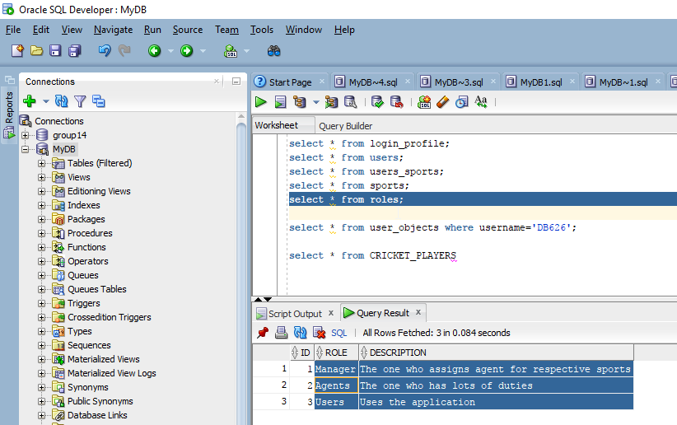

*Fig 11 Data for various Roles of actors in the system*

This data from the roles table is used to differentiate the data of users’, Agents and Managers. Based on this differentiation the actors are navigated to their respective home pages while logging into the application.

# 

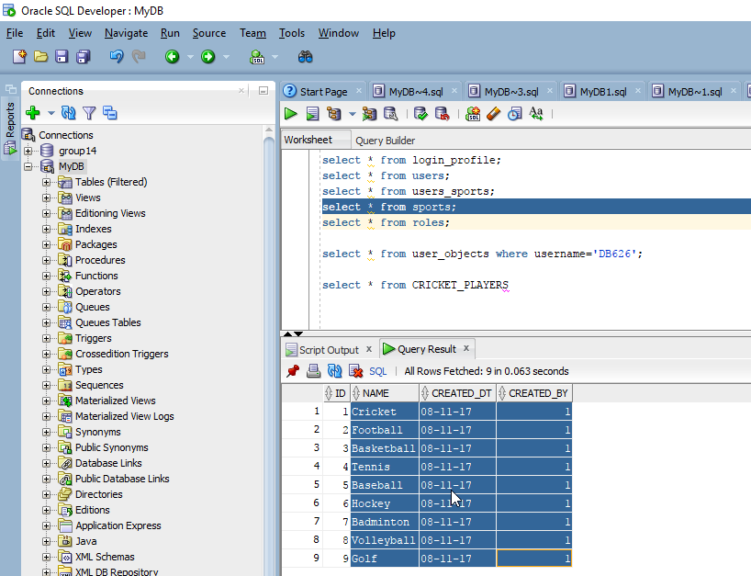

*Fig 12 Sports data of the Information system*

As the project scope is limited to 9 sports this is the data that represents the sports that are being delivered by this information system. The CREATED_DT represents when that sport has been added into the system. The CREATED_BY has the ID of the Manager who has added it into the system.

# 

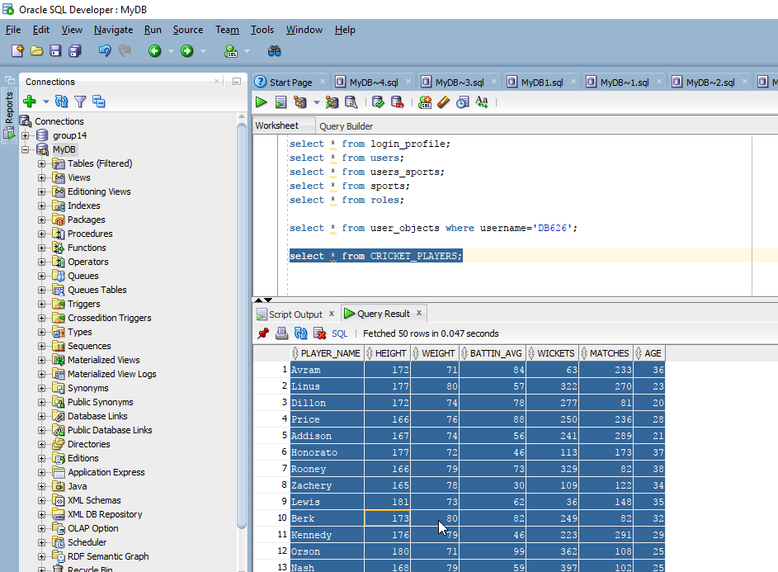

*Fig 13 Players Data for the Cricket Sport of the System*

The above data is the various players details who are related to Cricket sport. Similarly, we will be having the players details for all other sports too with their respective attributes. In addition to these the database also stores the tournament details, ticket vendor details and data related to the articles.

All these data from database can also be used for statistically analyzing the various aspects related to a sport like what is the sport majorly liked by the users of a location, Which player is performing well in a sport, which vendor is being mostly visited by the users and soon….

## Frontend View: Graphical User Interface

# 

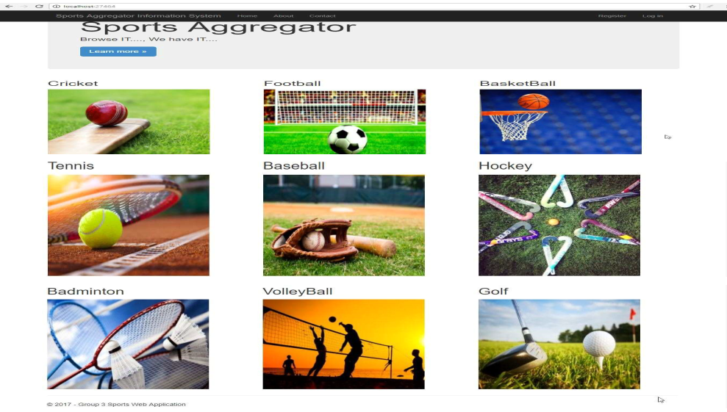

*Fig 14 Home Page of the Sports Aggregator Information System*

This is the home page of the Sports Aggregator Information System, where users’ can get a brief idea about the system and about any sport by clicking on the images of those sports. Then they can register and login to the system.

# 

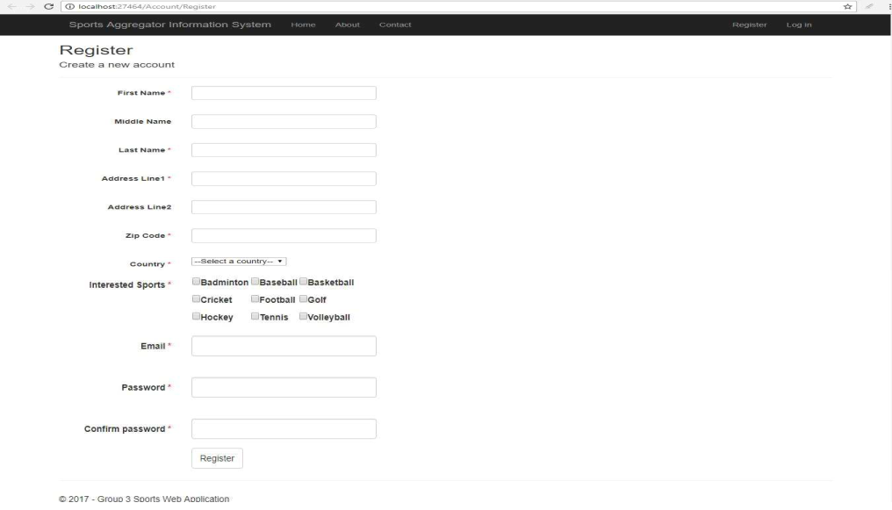

*Fig 15 Registration Page of the Information System*

In this page, the Users’ provide the details for the mandatory fields and selects their interested sports for which they require the Information from the system.

# 

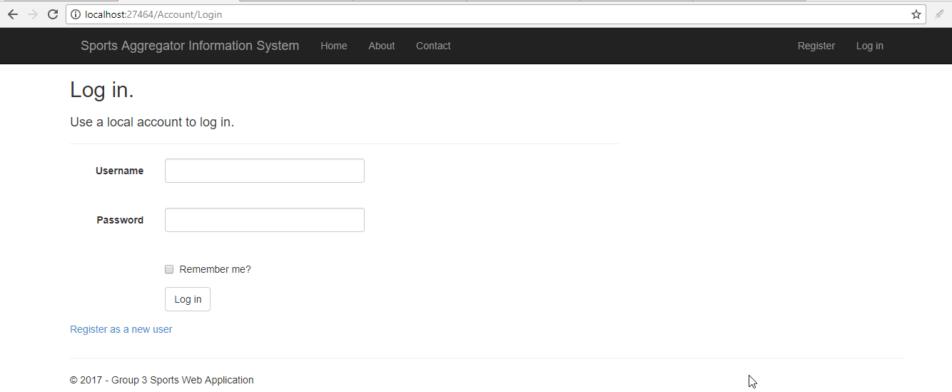

*Fig 16 Login Page of the Information System*

# 

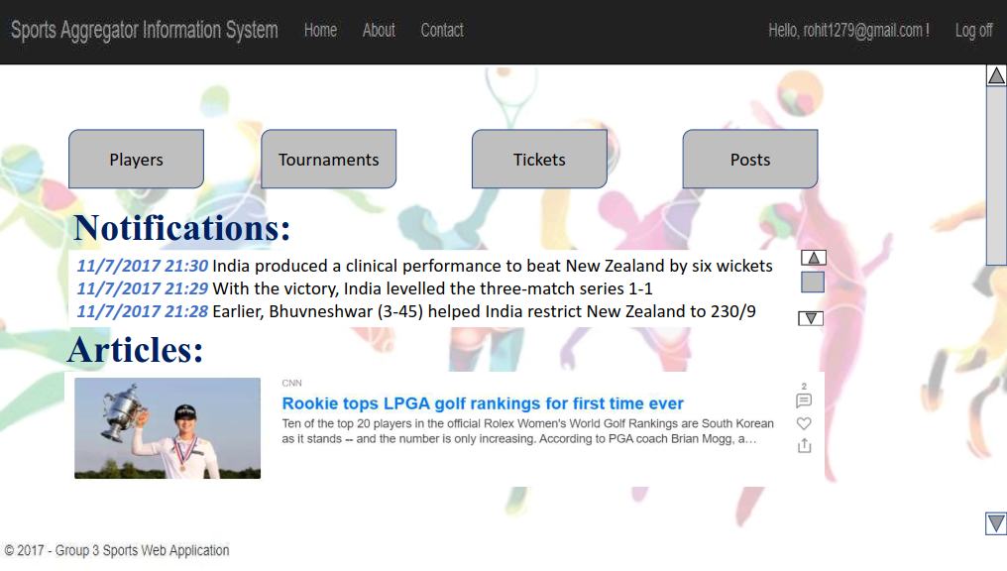

*Fig 17 Users’ Home Page of the Sports Aggregator Information System*

This is the homepage of a user in the Information System. Here, they get all the notifications posted by the Agents and articles posted by both Agents and users’. From this page they can navigate to the other pages like Players, Tournaments, Tickets and post articles as per their interests.

# Conclusions

In Conclusion, “Sports Aggregator” Information System addresses the exact requirements of users by providing the blend of user interaction along with an Expert Authentication. In this information era as there is huge piles of data regarding various sports it has become imperative to provide information in a focused manner based on the selectivity of the user and this is explicitly served by our information system.

# Recommendations

This information system is recommended to the users because of the below mentioned Unique Selling Propositions:

* Both Expert and User Interactive System
* Content Specific to interests of User
* Personalized Email Notifications
* Provision for purchasing tickets

The post article function of this system ensures that the users of published articles will be recognized by other users of the system if the article is well crafted with critical insights. Frequency of Email notifications can be personalized/customized based on the users’ requirement.

By incorporating the below recommended additions into our information system in future, it can be developed to serve the entire sports market.

* Increase number of sports: Our information system is providing data only pertaining to 9 sports but with proper infrastructure and resources it can be expanded to all the sports.
* Migrate from existing Oracle Database to NoSQL: By implementing this add-on to the system we can further provide unstructured data like video and audio content.
* Increase visibility with the Ticket Vendors: By improving the information system with the above modifications, we expect to increase the number of hits by multifold which in turn attracts more ticket vendors
* Provision to buy sports Merchandize on our system: Facility to purchase sports items like sports kit, Video Games, Sportswear, Fitness Equipment, Books, ….

# Lessons Learned from Project and Course

From the process of implementing this information system, we have learned different phases of an information system prior unleashing to the world. The approach we have followed for implementing this information system is CIDI (Clarify, Ideate, Development and Implement).

**Clarify:** In this phase we have thoroughly understood the problem in various perspectives which has helped us in later phases of approach.

*Albert Einstein is quoted as saying, “If I had an hour to solve a problem and my life depended on the solution, I would spend the first fifty-five minutes determining the proper question to ask, for once I know the proper question, I could solve the problem in less than five minutes.”*

**Ideate:** During this phase, we have listed out different ideas which would address the problem.

**Development:** This is the crucial phase of designing the system. By balancing the requirements and constraints we came up with a feasible solution in this phase.

**Implement:** Here finally the information system has been implemented based on the solution that has been derived in the development phase.

From the whole process of System Analyzing and Designing, we learned:

* How to visualize an information system by using the conceptual model diagrams
* How to gather good requirements and specifications
* Different phases in designing a solution from the requirements
* Different methods and processes followed in developing software information system
* How to implement and test an information system

**Appendix A: Glossary**

|  |  |
| --- | --- |
| **Acronym** | **Abbreviation** |
| USP | Unique Selling Propositions |
| HTTP | Hyper Text Transfer Protocol |
| HTTPS | Hyper Text Transfer Protocol Secure |
| URL | Uniform Resource Locator |
| ASP | Active Server Pages |
| PL/SQL | Procedural Language/Structured Query Language |
| JDBC | Java Database Connectivity |
| SMTP | Simple Mail Transfer Protocol |
| REQ | Requirement |
| DESC | Description |
| SVN | SubVersioN |
| DB | Database |
| API | Application Programming Interface |